**A Wise Man from the East**

Felicia R. Scatcherd

(“Felix Rudolph”)

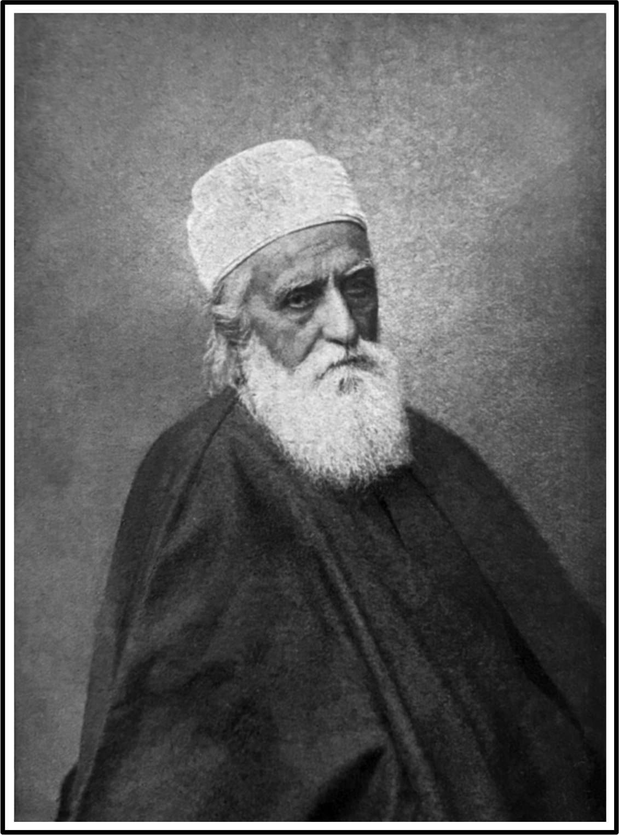

**Abdul Bahá**

**A Wise Man from the East**

Felicia R. Scatcherd

(“Felix Rudolph”)

Reprinted from the *International Psychic Gazette*, Jan. 1913

When Abdul Baha first came to England, I refused all invitations to visit him. I had met those who had made pilgrimages to his prison-home in Akka, and they talked so much about “The Blessed Perfection” and “The Manifested Splendour” that, though interested in what seemed a useful enough form of hero-worship for those to whom it appealed, I had no desire to see Abbas Effendi for myself.

Yet from the first moment that I heard of the Bahai movement I recognised its value, and in London and Paris promoted its interests whenever the occasion occurred.

One day in February, 1907, I met that earnest Bahai, Mr Arthur Cuthbert. He introduced his companion, Mr Sidney Sprague, as one who had come from America to spread the Bahai teaching.

Mr Sprague had been sometime in England, but progress had been slow, and he was slightly disheartened.

I took my card from my pocket, and giving it to Mr Sprague, said: “tell the Editor of the *Review of Reviews* I want him to interview you.

If he does this, and becomes your friend, you will have all the impetus you need.”

That one page interview in the March number

of the *Review of Reviews* for 1907, written by Mr W. T. Stead, still seems to me one of the clearest summaries of the Bahai teachings.

From time to time I attended a Bahai assembly, but remained as aloof from its influence as ever. In European Turkey where it was most needed it made little progress. I had pointed out to Ahmed Riza, then President of the Turkish Chamber, and others, how grievous it was for their country, that the Young Turk Reformers were mainly Positivists or Atheists, and suggested the initiation of a movement that should attempt to bring out the spiritual truths of Islam while dropping the accretions of the ages. But these well-intentioned Rationalists only began to attend the orthodox services in their mosques, and the people despised them yet more heartily for this sad surrender. So I had only made matters worse. I was somewhat indignant that the drawing rooms of London, Paris and New York were coquetting with this newer faith, instead of endeavouring to spread it among the peoples whence it had sprung, who were in sore need of its enlightenment.

Then in the spring of 1911, a clear friend compelled me to accompany her to a reception of Abdul Baha, then, as now, the guest of Lady Blomfield, of 97 Cadogan Gardens. The submissive sweetness with which the venerable man received the homage of his followers affected me strongly. I wondered whether, like the gifted Heinrich Heine, he ever shrank from the burden of an enforced role of divinity. And an impulse seized me to see him in converse with an intellectual and spiritual peer. But when I cast about to find such a one, I realised the true greatness of the man in

whose presence I found myself. I did not go forward with the rest to greet him on this first occasion. I stood at the door busy with my thoughts. And as if lie knew these thoughts, as he passed out, he gave me a playful slap on the arm, as one would administer reproof to a wilful child, and his eyes danced with merriment.

Again and again I have noticed evidence of his awareness of the mental states of those around him. And I am assured that this keen intuition has been observed in his correspondence. Those whom he has never seen have been amazed to receive, from the Prophet in Akka, correct perceptions of conditions pertaining to them in America.

Then it occurred to me that Mr Stead was the person I wished to see in converse with the teacher from the East. During that memorable meeting I gained much insight into the characters of these two remarkable men. Abbas Effendi was delighted when he learned that, from its inception, the *Review of Reviews* had been already a pulpit from which the leading tenets of Bahaism had been vigorously enunciated.

To explain how I obtained the portrait published in this month's *Gazette*, I will quote from one of my note books:

*Alexandria*, Sun. 21 Jan. 1912. A beautiful morning, my second Sunday in Egypt. We are on our way to see Abbas Effendi, Dr and Mrs Platon Drakoulès and myself. I had met this leader and inspirer of his fellows many times before under the grey skies of London, when his smile of sunny welcome seemed to atone for the absence of the sunshine, due even on an English autumn day.

Years ago, Mr Sidney Sprague, had been the guest of Dr Drakoulès, and had held a Bahaist meeting in the Doctor's Oxford home, when he had ardently desired that the Greek Reformer should make the personal acquaintance of the “Great Teacher from the East”. And now by a strange

coincidence this wish was to be realised, and Mr Sprague was to be the interpreter between these two devoted souls—the younger standing for the Social Regeneration of Mankind, the elder representing Spiritual Illumination and Unity.

In London, surrounded by the leaders of Western thought, Abdul Baha had rendered null and void Kipling's dictum:

“For East is East, and West is West,

But they twain shall never meet.”

Here, in the East, I wondered what effect would be produced upon us, where his picturesque personality had no longer the charm of uniqueness.

We found him in a villa, opposite the new Victoria Hotel, Rameleh. Although only 10 am, he had been astir for hours, attending to his enormous correspondence, and receiving visitors. Again, in his presence, the old sense of goodness and simplicity overwhelmed one. The venerable figure in its Persian costume, was just as unique in its Eastern setting, as in London.

Of middle-stature, and broadly-built, he yet strikes one at times, as if he were tall, and is undoubtedly imposing. Oval-faced, and large-featured, with heavy eyebrows, a nose resembling that of General Booth, he has the compelling personality of all born leaders of men. His grey eyes are unusually expressive. In moments of excitement they become dark and deep in the piercing intensity of their gaze. I have seen them flash as if generating a kind of lightning, and then they soften and brighten and change expression with all the varying moods of his active mentality. But whether under the influence of sorrow or joy, indignation or pity, they are always surcharged with sympathy. One who knows no word of Persian can share the emotions of his soul by watching the lights and shadows in his eyes. When, as often, he closes them, then one need only follow the movements of his no less wonderful hands.

I will not dwell on the details of the glad welcome, the oriental hospitality, the fragrant Persian tea, and the groups of waiting disciples from all quarters of the globe. I will only summarise the points in the discussion not generally dwelt on:

Dr Drakoulès asked, whether Abdul Baha did not think that injustice in industrial arrangements, resulting in antagonism between classes, owing to the existence of extreme poverty and excessive riches, militated against his teachings of Love and Unity.

He replied, that he could assure him on the authority of his father, Baha'u'llah, that the legislation of the world was

approaching a time when it would become illegal to own more than a certain amount of wealth. He added that the principle of unity was asserting itself more and more, and that under its influence, class antagonism will be recognised as immoral. This led the conversation to the subject of ethics, especially in relation to the lower animals.

Dr Drakoulès asked, whether he did not hold it to be immoral to exploit the sub-human races for our benefit, either in the domains of science, diet, or amusement?

Abdul Baha gave a definite reply in the affirmative. That is, he emphasised his belief that the destruction of humble life for the benefit of human life was inconsistent with the principle of Unity. He said, that this teaching would become accentuated later on. At the present time mankind is not ripe for certain aspects of truth. Even as Jesus, the Christ, refrained from saying to the world at large what he deemed it necessary to impart to his esoteric circle, so he, Abdul Baha, felt his general teaching circumscribed by the same necessity. But further manifestation of the Divine would lead to freer and fuller exposition of the fact of the Oneness of all Life—the basic principle of unity or love.

While in Cairo we made the acquaintance of other members of Abdul Baha's family. His daughters came to see us, and we visited the Bahai centres there, as well as the home of our good friend Mr Sprague, who had married a niece of the Master, to whose cause he is devoting his life.

On our return to Alexandria, I went again to Rameleh, to obtain permission for a Greek painter, of great talent (Madame Thalia Caravias), to make a painting of the Master. This permission was accorded, mainly, I believe, owing to his daughter's persuasion. You see, I felt unless the prophet adopted the veil the women were casting on one side he could not avoid portraits being taken. One fine one had already been made, and he had been photographed several times without permission. Then he gave me the now well-known photo at the head of this article, with leave to do what I liked

with it, so I have let the Editor use it for his Portrait Gallery.

I wished Mr Lewis to see Abbas Effendi for himself. And Lady Blomfield kindly arranged an interview for us on the 2nd of January.

Mr Child, the well-known palmist, also accompanied us. I longed, in the interests of science, to get impressions of those marvellous hands, should Abdul Baha not object.

Mr Lewis put questions on reincarnation, the immaculate conception, etc. In answering the latter question, Abdul Baha finished with one of his quaint observations, to the effect that to those who accepted the creation of the first man without any human parent, it should not be difficult to accept the birth of a being with one human parent only!

His answer about reincarnation was very interesting. In the *Contemporary Review* last year, an article appeared by that able writer, Constance Maud, in which the Master's views on the subject are given at length.

Then delicious tea was served in Persian fashion. It made me feel I was back in Egypt, and I dared again to make a request. The kind and eloquent interpreter (Mirza Ahmad Sohrab) explained my wish, and Abdul Baha submitted to the process of having an impression of his hands taken, with the utmost graciousness and good-will, and signed the four imprints, which I hope will appear in next month's *Gazette*, with Mr Child's delineation.

“Now, Mr Editor, what are your impressions of this Teacher from the East?”

Here is what he thought. I quote him without his permission, and he will have to let it stand or fill up the gap it leaves:

He is the positive strong man, the father, the pioneer, the leader, the man of dogged determination and perseverance; combined with the negative gentle man, the mother, the shepherd, the man of patience and sympathy, intuitive and spiritual, teaching by symbols and parables, rather than by logical appeals to the intellect. He is the mystic and the initiate who has received his divine illumination in the silence and the solitudes, and whose greatest difficulty in life will probably be to find in this mundane world, audiences to understand and appreciate his mystical inspirations.

Now for a word as to the Bahai religion and its teaching.

The existence of a Supreme Being, the God of all religions, and of a spirit in man which survives the death of the body, are regarded as foundation principles, never to be called in question.

The chief Positive Teachings may be briefly summed up as follows:

The union of all races and religions.

The abolition of warfare and the establishment of international arbitration.

The adoption of a universal language.

The equality of the sexes.

Monogamy, as opposed to celibacy or polygamy

The equal education of all children—girls as well as boys—as a religious duty.

The exercise of some profession, art or trade, compulsory for all adults

The provision of work for all.

The principal Prohibitions are equally wise and essential:

Any special priesthood, apart from the laity, asceticism, or living in seclusion, mendacity, slavery, cruelty to animals, gambling, the taking of opium and alcoholic beverages, are all alike, strictly forbidden.

I will conclude this desultory paper by

quoting from Abdul Baha's Tablet to the Bahais of England:

O ye Sons and Daughters of the Kingdom!

* * * * *

“It is easy to accept the Kingdom, but it is difficult to endure therein, for the tests are hard and heavy. On all occasions the English are firm … being neither prone to begin a matter … nor ready to abandon it for a little reason ….

Verily in every undertaking they show firmness.

“My hope is this:—that the outbreathing of the Holy Spirit be inspired into your hearts; that your tongues begin to reveal the mysteries and to expound the meaning and the truth of the Holy Books. May the friends become physicians, to cure by the Divine Teachings the deep-rooted diseases of the body of the world, to give sight to the blind, hearing to the deaf, life to the dead, and awakening to the sleepers. Be sure that the blessing of the Holy Spirit will descend upon you, and that the Hosts of the Kingdom will come to your aid.

“Upon you be the Glory of God.”

(Given at Ramleh, Egypt, May 1911. Translated by Tamadum ul Mulk).

John Lewis & Compy., 5, Bridewell Place, Ludgate Circus, London, E.C.

Bahai literature

The Hidden Words, Communes and Prayers.

By Baha'u'llah … … 4d., by post 5d.

The Seven Valleys. A mystical treatise.

By Baha'u'llah … 1s. 2d. by post is 1s. 3d.

The Book of Ighan (Certainty)

By Baha'u'llah … 4s. 7d., by post 4s. 11d.

A Brief Account of the Bahai Movement.

By E. J. Rosenberg … 1d., by post

In Galilee

By Thornton Chase 1s. 7d., by post 1s. 9d.

A Year with the Bahais in India and Burma

By Sydney Sprague, PRIORY PRESS 1s. ,, 1s. 2d.

The Splendour of God

By Eric Hammond. MURRAY 2s. ,, 2s, 21/2d.

Bahaism. The Religion of Brotherhood (an illuminating retrospect on the evolution of Truth, up to its realisation in the station of Service). By F. H. Skrine. Longmans … … 1s. 6d., by post 1s. 7½d

Abdul Baha in Paris (Addresses and notes of conversations, dealing with many subjects not referred to in London).

By Abdul Baha … … 2s., by post 2s. 2d.

Abdul Baha in London (Addresses and notes of conversations) … … … … 1s., by post 1s. 2d.

_________________

The Unity Press,

47 Vicarage Road, East Sheen, London, S.W.