Who Will Bell the Cat?
'Abdu'l-Bahá at Lake Mohonk
Janet Ruhe-Schoen

From the old stone tower at Sky Top a hiker can look out over rockbound Lake Mohonk, forests full of secret glades and the farm fields of the Walkill and Roundout Valleys to the blue horizon of the Catskills. Sky Top is a great place for visions, and that's why it was well-loved by Albert Smiley.
The lake and its 300 acres of surrounding land has belonged to the Smiley family since Albert bought it in 1869. Through Albert's aesthetic stewardship and the business sense of his brothers the property expanded and the resort flourished. By 1900, the Mohonk Mountain House, a huge, rambling, turreted castle of a hotel, stood guardian over the lake, and there it has been ever since.
Albert Smiley was 41 years old, the Quaker principal of the Friends School in Providence, Rhode Island, when he bought the property from a tavern-owner with money that he and his frugal wife had saved. The Smiley idea was to build a resort. Albert later said that the thought of owning a resort was, to him, like the notion of going to the moon. But his brother, Alfred, who owned a farm near Poughkeepsie, encouraged him to buy the place. Albert had business acumen, and enlightened management soon transformed Mohonk. The open-all-night bar, where drunks used to be chained to trees until they sobered up, disappeared. In its place stood a retreat for high-minded cognoscenti with daily worship services and no alcoholic beverages served on the premises. Conserving the wilderness, Albert carved gardens out of a rocky hillside and hiked the mountain woodlands constantly, designing trails leading to gazebos at spectacular overlooks.
He also initiated several social projects, among them the Lake Mohonk Conference on International Arbitration. This institution worked year-round through correspondence, and each spring Mohonk hosted a yearly gathering for its members. The work was, as stated in the preface of the report of the 18th annual conference, "for the purpose of creating and directing public sentiment in favor of international arbitration, arbitration treaties and an international court."
The institution held its first conference in 1895, and endured until World War I. After a long hiatus lasting through the Depression and World War II, the Smileys at Mohonk again hosted peace consultations, some of them for the United Nations. Currently, the Smileys continue to use what's been called the Mohonk mystique to bolster peace efforts that the family feels are worthy, especially environmental protection programs aimed at diminishing poverty. So historic Mohonk still functions vitally. Memories of its past remain in architecture and artifacts, among them photos in Mountain House hallways of distinguished early-20th Century visitors and supporters including the steel magnate and philanthropist Andrew Carnegie and the naturalist John Burroughs. Among the pictures of these grave-looking men is one of 'Abdu'l-Bahá, white-bearded, crowned with a turban, gently smiling. Someone remarked that 'Abdu'l-Bahá walked at once like a shepherd and like a king, and there is the simplicity and majesty of a shepherd-king in his face.
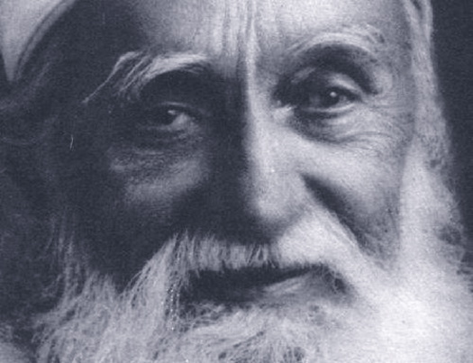 'Abdu'l-Baha, ca. 1912

'Abdu'l-Bahá'íá came to Mohonk at Albert Smiley's invitation in 1912 to address the arbitration conference. The name 'Abdu'l-Bahá means Servant of Glory. 'Abdu'l-Bahá was the son of Bahá'u'lláh, whose name means The Glory of God. Bahá'u'lláh founded the Bahá'í Faith in 1863 in Baghdad, Iraq, where he was in exile from his native Iran because of his religious teachings, considered heretical by Iranian authorities. When he died in 1892 near Acca, Israel (then a penal colony in Palestine), he was still an exile, prisoner of the Ottoman Empire. He'd suffered years of brutality, but his faith was established as far east as India.
He had promised that soon it would reach the West. In 1893, a Christian missionary spoke his name from a public platform for the first time in North America at the World Parliament of Religions in Chicago. By the turn of the century Bahá'í groups were established in North America and Europe. In 1898, the first group of Bahá'í pilgrims from the West joined Bahá'ís of the East in prayer at the Bahá'í Shrines in Haifa and Acca, and they 'Abdu'l-Bahá, who had shared his father's exile and imprisonment and still was not a free man.
'Abdu'l-Bahá was named by his father the perfect example of a Bahá'í, the Master, the Mystery of God, but he preferred to be called a servant and said that servitude was his crown. He regarded himself as one of the poor of the earth, a homeless wanderer, but a true wealth of solace flowed from him as he constantly provided for the sick, the hungry, the despairing. An increasing number of pilgrims from Europe and North America continued to visit him, and they longed for him to bring his solace to their homelands. Finally the Young Turks Revolution dealt the last blow to the Ottoman Empire and 'Abdu'l-Bahá was free.
He arrived in the United States on April 11, 1912. He came at the invitation of the Bahá'ís there but he also told a fellow-passenger, a newspaper owner, while crossing the Atlantic on the steamship Cedric, "I am going to America at the invitation of the Peace Congresses of that place, as the fundamental principles of our Cause are universal peace, the oneness of the world of humanity and the equality of the rights of men..." When the ship docked in New York and the gangplank was lowered, the press clambered aboard to interview him and he told them, "Our object is... the unity of mankind... I have come to America to see the advocates of universal peace..."
As his statements frequently made plain during his nine months in the U.S., 'Abdu'l-Bahá'íá foresaw the coming of World War I and to somehow influence world thought and spirit so it could be avoided. But he wasn't given to wishful thinking; his hope, though heartfelt, wasn't high. For him, the Mohonk Conference was one of several opportunities to present his message to people who were specifically and consciously seeking peace, was sure his efforts and counsels would bear fruit, if not immediately, then in the future. To that end, he had written to Albert Smiley and to H.C. Phillips, secretary of the Mohonk arbitration institution.
He wrote to Albert Smiley on August 9, 1911, from Egypt, when he was about to depart on his first voyage west, to Europe. On August 22, from Switzerland, he wrote to H.C. Phillips. Those letters are unusual in that 'Abdu'l-Bahá'íá wrote them without first receiving letters from Smiley or Phillips. Generally, he didn't initiate correspondence.
It's probable that he was inspired to write them because one of his most valued companions and translators, Mirza Ali Kuli Khan, was in the U.S. and had addressed the 1911 Mohonk conference. Khan was carrying out a mission given him by 'Abdu'l-Bahá'íá to try to create bonds of friendship and business between the U.S. and Iran (then called Persia in the West). This mission had nothing to do with the government of Iran, to which 'Abdu'l-Bahá'íá was anathema. 'Abdu'l-Bahá' wanted to try to help his native land through Khan's individual effort; to that end he'd guided Khan's education and career. This mission, requiring incredible self-sacrifice on the part of Khan and his American wife, Florence Breed, was doomed, at least apparently, but Khan couldn't have known that in the early 1900s.
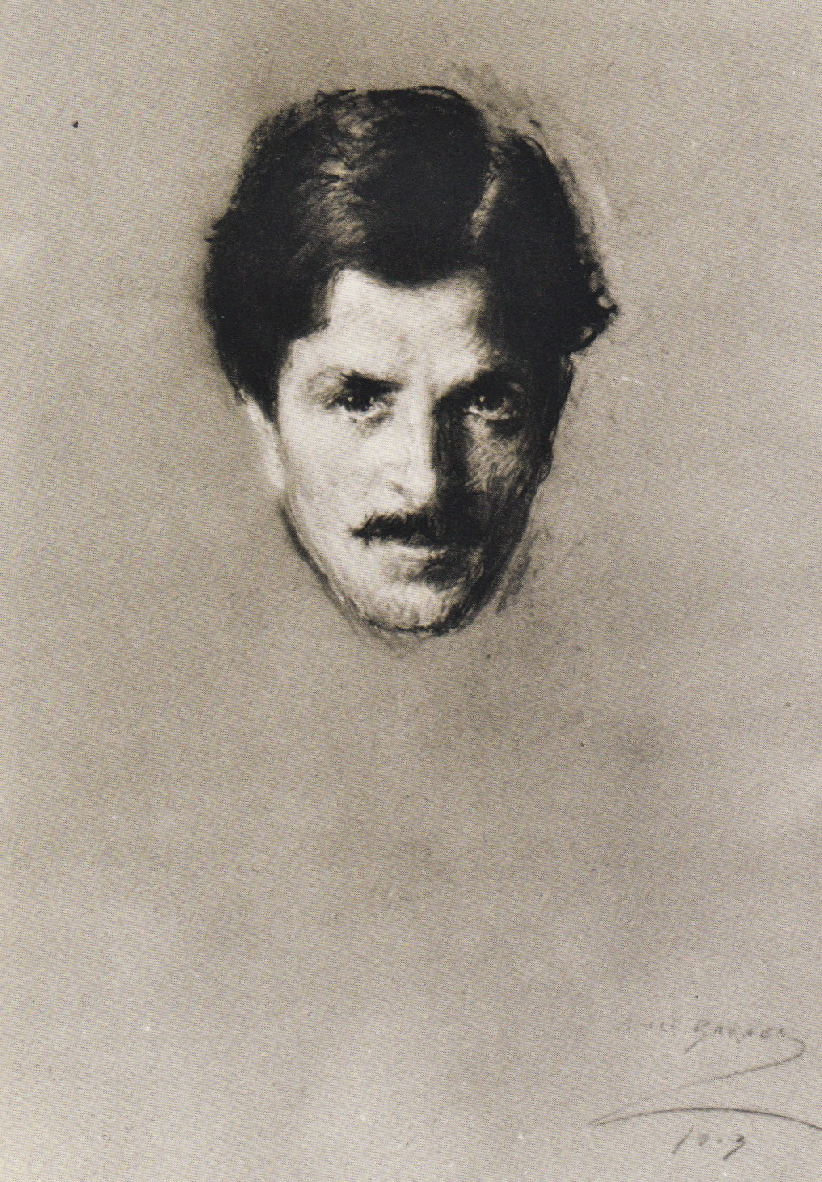 Ali Kuli Khan, ca. 1912, portrait by Alice Barney

Acting as Charge d'Affaires for the Persian Legation in Washington, D.C., Khan followed the Persian custom of heading for the hills during hot weather and packed his office off to the Catskills. Perhaps he first met the Smileys during one of those summers. However it happened, he was invited to speak at the 1911 arbitration conference.
Opening that conference, Albert Smiley cited instances of successful arbitration in the world, pointed out that the movement had the support of the U.S. President William Howard Taft, and concluded, "I cannot help saying again how intensely happy it makes me at my time of life to see this great movement assuming its proper position in public affairs." The presiding officer of the conference, Nicholas Murray Butler, president of Columbia University and of the Association for International Conciliation, said the moment was one when "feelings of exhilaration and enthusiasm" were high. "Never before," he added, "has the mind of the world been so occupied with substituting law for war, peace with righteousness..."
When Ali Kuli Khan spoke, however, he wasn't quite so optimistic. He said that widespread injustice was still rampant and he seemed particularly offended by colonialism. "The term 'civilized world,'" he said, "should be broadened to embrace all mankind. As long as the strong is allowed to promote his selfish end and shield his wrong-doing under a plea for the spread of civilization... our hope for the peace of the world will fall short of realization..." He issued a prescient warning that "complaints of weak and seemingly insignificant nations should be allowed to reach the ear of the world peace movement. They should not be passed with indifference, or mistaken for expressions of local discontent. To involve nations in war, no cause is too insignificant, and history recalls that many wars started from unimportant localities..."
Khan was a well-informed and skeptical observer of human affairs who, perhaps, would not have believed in the possibility of world peace without the influence of 'Abdu'l-Bahá, who wrote to H.C. Phillips, "About sixty years ago, His Highness Bahá''u'lláh through the Heavenly Power proclaimed the oneness of the Kingdom of man in that country (Persia) and addressing the concourse of humanity said: 'O ye people! Ye are all the fruits of one tree and the leaves of one branch!'"
He mentioned that in his Book of Laws Bahá'u'lláh "commanded the people to establish the Universal Peace and summoned all the nations to the Divine Banquet of International Arbitration." He propagated the necessity for collective security, saying that, once an international treaty requiring arbitration of all disputes is made, "if at any time any nation dares to break such a treaty all the other nations must arise to put down this rebellion."
No wonder that he was invited to address the 1912 Mohonk conference. When he arrived at Lake Mohonk in May of that year, his dignity and presence were such that his hosts could have no way of knowing that he'd only become speaking from public platforms the year before, in London. He'd been an exile and prisoner from childhood until the age of 65. He viewed himself as an exile until the end of his life. His address is given in the Mohonk guest book simply as "Persia." He hadn't resided there since mobs sacked his family home in 1853. He was 68 in 1912, no stranger to pain, fatigue, illness and sorrow, but he radiated vigor and joy, animated by a love for God and humanity. He longed to see his father's message heal the world and he trusted that one day it would, but he knew what the world would endure, first.
Even Albert Smiley, opening the 1912 conference, wasn't as optimistic as he'd been the year before. He said he was "gratified that so many leaders of American and European thought" were present, because he knew that "events since the last conference" had "caused disappointment and even discouragement to many persons interested in the international peace movement." He was referring specifically to a setback in the U.S. Senate in the process toward unilateral acceptance of the arbitration method. He cited disputes that had successfully come up before the Hague Court for arbitration, and only mentioned in passing the war between Italy and Turkey. But the next speaker, Nicholas Butler, pointed out that, despite signing the 1899 Hague Convention, Italy and Turkey had gone to war without trying arbitration.
'Abdu'l-Bahá, presenting the first address during the second session of the conference on May 15, was all too aware of the disposition of humanity towards war but he didn't dwell on it. His speech was shorter than Khan's had been the year before, and it was shorter than most addresses at such conferences. He mentioned Bahá'u'lláh and told how his teachings united Bahá'ís of traditionally warring backgrounds: Muslims, Christians, Jews, Zoroastrians; Kurds, Arabs, Persians, Turks. He listed Bahá'í principles as a basis for peace: the one divine foundation of religion and the purpose of religion as a bond of love and unity; the oneness of the human race and the equality of men and women; the harmony of science and religion; the abolition of extremes of wealth and poverty. He concluded, "...philosophy does not suffice and is not conducive to the absolute happiness of mankind. Great philosophers have been capable of educating themselves, or a few who followed them, but generally they could not endow ethical education. Therefore, the world of humanity is evermore in need of the breath of the Holy Spirit. The greatest peace will not be realized without the power of the Holy Spirit."
Dr. Zia Baghdadi, who accompanied 'Abdu'l-Bahá to Mohonk and helped interpret for him, said that, after delivering the address, 'Abdu'l-Bahá'íá remarked privately, "Once I wrote to the friends in Persia with regard to peace congresses and conferences, that if the members of the conferences do not succeed in practicing what they say, they may be compared to those who hold a meeting to discuss and form firm resolutions about the sinfulness and harmfulness of liquors, but, after having the meeting, occupy themselves in selling liquors... Now we must not only think and talk peace but we must develop the power to practice peace so that... peace may permeate the whole world."
'Abdu'l-Bahá, spending the next day at Mohonk, took an afternoon walk accompanied by a group of young men and women. He stopped beneath a big, blossoming tree and smilingly regarded the youth. The sky was cloudless and blue, the sun warm, the mountainsides green. Baghdadi recalled, "Everything was quiet except for the melodies of songbirds and the gentle breeze that whispered to the leaves." 'Abdu'l-Bahá broke the silence, announcing to the youth that he would tell them an oriental story, the old fable called Belling the Cat.
The rats and mice held a conference on how to make peace with the cat. After loud and heated debate, they finally decided to tie a bell around the cat's neck so they'd hear him coming when he was on the prowl and could get out of his way. Enthusiasm reigned until one mouse – or was it a rat? -- asked, "Who will bell the cat?" The rats weren't willing and the mice felt too small and weak. So the conference broke up and the cat stayed on the prowl, unrestrained.
'Abdu'l-Bahá's little audience laughed, and he laughed, too. He had a ringing, infectious laugh. Then silence fell again. After awhile 'Abdu'l-Bahá said that words spoken in peace conferences didn't mean much if no one resolved to bell the Czar of Russia, the Emperor of Germany, the President of France, the Emperor of Japan. Everyone became grave, but 'Abdu'l-Bahá'íá laughed again and assured them that peace would come and aggression would be quelled through spiritual power.
The next day 'Abdu'l-Bahá sent Zia Baghdadi off on a memorable adventure when he said, "We have to leave this place tomorrow and I wish I had one of my Persian rugs here, that I might give it as a present to our host, Mr. Smiley." His companions reminded him that he was to leave Mohonk at 10:00 a.m. and it would be impossible for anyone to get to New York City, pick up a rug, and be back in one night. 'Abdu'l-Bahá looked at Baghdadi and asked, "Well, what do you say?"
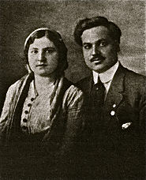 Zia Baghdadi with his wife, Zeenat Khanum

Baghdadi said yes. 'Abdu'l-Bahá'íá handed him the key to the room in New York where the rugs were. "May God bless you," he told Baghdadi. The young man hired a carriage and rushed to the train station, where he learned that no passenger train was leaving for the city just then. But a freight train was just pulling out. He later reminisced, "I jumped the tracks and made a wild dash... Finally I caught the rear end of that speeding train and succeeded in climbing up... Then while I was trying to catch my breath the conductor came and ...ordered me to get off at the next station. I showed him my professional card and told him I was going on a very urgent mission. 'Oh you are a doctor! That is all right.' Fortunately the kind conductor didn’t ask what the urgent call was.
"About two o'clock in the morning I reached 'Abdu'l-Bahá's apartment and had to awaken Mrs. Grace Ober and her sister, Miss Ella Roberts, to let me in. They were very kind and asked me to have something to eat and to rest awhile, but I thanked them and told them I was in a great hurry. Then I selected one of the most precious rugs from 'Abdu'l-Bahá's room and hastened to the railroad station. I took the first early morning train. It was about nine o'clock when I arrived at Lake Mohonk station. From the station it would take one hour to reach Lake Mohonk by carriage, and I had to be there at ten o'clock. I looked around, and there was no vehicle of any kind in sight. But finally the mail-carrier appeared with his little wagon and got off at once to receive the mail. I got on the little wagon and awaited his return. When he came and saw me, well! Was I nervous? It was certainly one of the most embarrassing moments of my life. However, I explained my position to him, that I was in the service of 'Abdu'l-Bahá, whom we regarded as our spiritual king, and I showed him the rug that had to be delivered right away to Mr. Smiley... Then as a last resort, I suggested that in case it was against the law to let me go with him, he could at least let me relieve him that morning because I knew how to drive a horse, and if it was necessary he might consult with the post office or the police... What a relief came when he said, 'It's all right I guess, I was going up there anyway.'
"We arrived at our destination just at the time when 'Abdu'l-Bahá was shaking hands with Mr. Smiley and preparing to leave. He took the rug with a smile and presented it to Mr. Smiley... 'Why this is just what I have been seeking for many years,' Mr. Smiley exclaimed. 'You see we had a Persian rug just like this one, but it was burned in a fire and ever since my wife has been broken-hearted over it. This will surely make her very happy."
Shortly after that, just as 'Abdu'l-Bahá'íá was departing, H.C. Phillips approached him and said, "We all appreciate your blessed visit and we believe that what you said is the truth. But we are sorry we cannot include religion in our organization. Our members are composed of all kinds of religions and sects -- the Protestant, Catholic, Jew, etc.; naturally, everyone prefers his own belief and will protest if any religion besides his own is favored."
'Abdu'l-Bahá replied, "Your members may be compared to beams of different metals and you are trying to unite them as you would tie these fingers together with a string," and he held up his hand, bringing his fingers close together. "See, no matter how you tie them, still they shall remain separate. But the only way to make these metals into one alloy is to put them into a crucible and apply intense heat to melt them all. For our melting-pot, we use the fire of the love of God."
Then 'Abdu'l-Bahá'íá left the deep, cool, rock-rimmed lake, the blossoming woods and the Mountain House. He journeyed tirelessly from coast to coast in the U.S., into Canada, on to England and France, Germany and Austria. He met the "friends of God" and the "advocates of peace." In the teeth of World War I he traveled back to Haifa and danger, for the land was torn by famine and warfare, and the Turks again regarded him as a threat to their dominion. At one point, he was threatened with crucifixion. Unperturbed, he continued his life-long work as a one-man welfare agency, using surplus grain he'd trained Bahá'í farmers to raise and store during the pre-war years to feed the needy, including soldiers of all nationalities, and he oversaw medical stations set up by Bahá'ís.
After the war, the British knighted him for his famine relief work. When he died in 1921, his cause, the Bahá'í Faith, was newly established in far flung places including Africa, Australia and Japan; at the same time, he had clearly glimpsed World War II on the horizon and had lamented the coming tragedies. But he was exhausted, and could do no more.
The question remains: Who will bell the cat?

Bibliography

'Abdu'l-Baha, "Tablets from 'Abdu'l-Baha," Star of the West, Vol. II, No. 15, Dec. 12, 1911.

Baghdadi, Dr. Zia, "'Abdu'l-Baha inAmerica," The Baha'i Magazine, Vol. 19.

Balyuzi, H.M., 'Abdu'l-Baha, George Ronald, Oxford, 1971.

Burgess, Larry E., Mohonk, Its People and Spirit, Smiley Bros., Inc., New Paltz, NY, 1980.

Gail, Marzieh, "'Abdu'l-Baha in America, the 25th Anniversary Observance," Baha'i News, April, 1987.

Ives, Howard Colby, Portals to Freedom, George Ronald, Oxford, 1974.

Report of the Seventeenth Annual Lake Mohonk Conference on International Arbitration, Lake Mohonk, 1911.

Report of the Eighteenth Annual Lake Mohonk Conference on International Arbitration, Lake Mohonk, 1912.

